Contents

Abstract 2

Introduction 2

Summary of Findings 4

Descriptive Statistics – selected from data set as a whole, influence factors 5

Pressure, temperature, PTF 5

Descriptive Statistics on summary of dose and its variation with gantry identity 6

Descriptive Statistics – tabulated Dose [Gy] for DoseConsistency reference MU proton beam 7

Boxplots - Tabulated Dose [Gy] for DoseConsistency reference MU proton beam; (median and boxplot) by Energy 8

Tabulated Dose (Robust mean) by Energy and separated by Gantry 9

Density Plots – Absolute Dose [Gy] for reference dosimetric consistency beam 11

Range of readings – indicative plots by gantry (and energy) 20

Plots of Dose measured by time 21

Appendices 26

Material too voluminous to include in report 26

Range of readings (rows of repeated charge readings in data) 26

Tables: Range Among separate readings taken for output Plotted by Gantry (and divided into Energy bands) 26

Heatmaps Dose Gy chambers by energy and gantry 29

# Abstract

Results and graphical display of survey of RW3 Dose Consistency “monthly” output event results data **(as per RTP 229: PBT output consistency check in RW3)**, data exported from Excel spreadsheets in T:\PBTQADATA. Sources have been stated (along with an attempt to provide a versioning edition control). Data referred to as “Gy” in the following are taken from the CSV versions of the excel spreadsheets in the collection done on 12 Jan 2023

Caveat: Data handling has been repeated and various stages of data preparation (filtering) have given rise to various parts of the reported data here. In particular, some of the results exclude some data labelled in the original as problematic – but most include all of it. This apparently inconsistent approach was taken for reasons of (a) learning how to pipeline the data (b) learning how to plot and subset the data appropriately. These challenges used most of the time. On this basis, it is not recommended that this particular edition is furthered outside the team in public, without a review of potential improvements were rework on dataset considered in terms of time / benefit.

The main types of data organisation presented is in terms of (a) pooled data (b) division into groups of subsets of data. The latter include subset by (a) gantry (b) energy and a little by (c) chamber. A preliminary display of influence parameters only includes atmospheric conditions, and currently excludes HV on chamber (all but one event set correct), operator (person). The indication parameter of ‘inter-reading range’ is considered, but relatively light in terms of statistical description – only plot and tables for this, which is enough to indicate a separation of gantry behaviours. Little can be said of causative factors.

# Introduction

There are some anomalies with the dataset used in all of the separate (JASP and R) processing reported on which are believed to have been introduced during initial conversion from original excel spreadsheets into CSV with additional rows copied down from row which characterises each measurement group (ie has full data record for the session). This a simpler version of this stage was repeated, and it is now believed that this stage (completion of all the interim rows for the same date) is not needed for the current analysis.

**Data referred to as “Gy” in the following are taken from the CSV versions of the excel spreadsheets in the collection done on 12 Jan 2023 and listed in table below.**

Table 1 Specification of data sources for report of 18 January 2023

|  |  |
| --- | --- |
| Directory listing | Image in zip compressed file containing prime data versions processed further (for audit purposes) |
| Directory of C:\Users\alemoore\Documents\DoseCons  **09/01/2023 15:29 1,671,019 OutputConsistencyRW3_G1v6.xlsm**  **10/01/2023 19:57 951,837 OutputConsistencyRW3_G2v6.xlsm**  **19/12/2022 17:22 664,565 OutputConsistencyRW3_G3v6.xlsm**  **09/01/2023 09:59 1,687,434 OutputConsistencyRW3_G4v6.xlsm**  **4 File(s) 4,974,855 bytes** |  |

Writing back out to file from R was done for two reasons, (a) audit and version control (b) subsequent rework.

|  |  |
| --- | --- |
| The files listed below include variations of format for separator and quotes for import back to excel (date gives version control information, latest being reference set, generated from intermediate files in next column) | The files listed below are written out intermediate files from R (date gives version control information, latest being reference set) |
| 11/01/2023 17:01 850,508 OutputGAll.csv  12/01/2023 11:29 1,055,307 OutputGAllxl.csv  12/01/2023 12:13 825,434 OutputGallxl2.csv  13/01/2023 15:38 823,876 OutputGallxl3.csv | 13/01/2023 15:01 191,421 OutputG1.txt  13/01/2023 15:15 430,989 OutputG2.txt  13/01/2023 15:20 120,778 OutputG3.txt  13/01/2023 15:21 390,059 OutputG4.txt |
| Within JASP, little intermediate processing was found necessary with the version OutputGallxl2.csv processed and stored in files as below | Analysis generated and printed to pdf in file below were also copy/pasted into word document (this report). |
| 16/01/2023 14:58 16,886,564 OutputGallxl2.jasp | 12/01/2023 14:38 3,453,924 OutputGallxl2.pdf |

Most of these files are included in the github site at the moment, pending team discussion as to best place. [ <https://github.com/UCLHp/OutputConsistency/tree/R%3Dreview/Rreview> ]Among other utilities (Notepad, VSCode, cmd prompt) used for file edit, manipulation and OS work, the main processing in this report is with the software tools in Table 2.

Table 2 Icons for software used in this report

|  |  |  |
| --- | --- | --- |
| JASP software | R software | R features that made processing and preparation useful include data storage objects (tibbles) and time-series tibble objects (tibbletk), and various packages (libraries) that create, manipulate and print these objects. |
|  |  | [ <https://cran.r-project.org/web/packages/timetk/vignettes/TK04_Plotting_Time_Series.html> ]  [ <https://cran.r-project.org/web/packages/timetk/vignettes/TK07_Time_Series_Data_Wrangling.html> ] |
| Excel | R Studio | Learning from various webpages on the fly has been used |
|  |  | [ <https://www.tidymodels.org/learn/models/time-series/> ]  [ <https://www.business-science.io/code-tools/2017/10/24/demo_week_timetk.html> ]  [<https://www.business-science.io/code-tools/2017/10/26/demo_week_tibbletime.html> ]. |

# Summary of Findings

Table 1 Specification of data sources for report of 18 January 2023 2

Table 2 Icons for software used in this report 3

Table 3 potential influence factors (pressure and temperature) 5

Table 4 Descriptive Statistics – tabulated Dose – grouped by gantry 6

Table 5 Descriptive Statistics – tabulated Dose – grouped by energy 7

**Table 6 Gantry 1 - dose consistency in RW3** 9

**Table 7 Gantry 2 - dose consistency in RW3** 9

**Table 8 Gantry 3 - dose consistency in RW3** 10

**Table 9 Gantry 4 - dose consistency in RW3** 10

Figure 1 Gy for DoseConsistency reference MU proton beam - Boxplot 8

**Figure 2 Frequency distribution of dose consistency output - Gantry 1 - all energies superposed** 16

**Figure 3 Frequency distribution of dose consistency output - Gantry 2 - all energies superposed** 17

**Figure 4 Frequency distribution of dose consistency output - Gantry 3 - all energies superposed** 18

**Figure 5 Frequency distribution of dose consistency output - Gantry 4 - all energies superposed** 19

**Figure 6 Range Among separate readings taken for output represented by rectanglesfor each part of range value** 20

**Figure 7 High Energies, Gantry 4** 22

**Figure 8 High Energies, Gantry 3** 22

**Figure 9 High Energies, Gantry 2** 23

**Figure 10 High Energies, Gantry 1** 23

**Figure 11 Low Energies, Gantry 4** 24

**Figure 12 Low Energies, Gantry 3** 24

**Figure 13 Low Energies, Gantry 2** 25

**Figure 14 Low Energies, Gantry 1** 25

# Descriptive Statistics – selected from data set as a whole - as insignificant influence factors

## Pressure, temperature, PTF

Tabulation and ASSUMED ‘insignificant’ variation between the gantries has currently deprioritised inclusion of these as influence factors (on dose or its variation) worth investigation further.

Table 3 potential influence factors (pressure and temperature)

|  | | TempC | | | | | | | | PresshPa | | | | | | | | TempPressC | | | | | | | |
| --- | --- | --- | --- | --- | --- | --- | --- | --- | --- | --- | --- | --- | --- | --- | --- | --- | --- | --- | --- | --- | --- | --- | --- | --- | --- |
| **GANTRY** | | **1** | | **2** | | **3** | | **4** | | **1** | | **2** | | **3** | | **4** | | **1** | | **2** | | **3** | | **4** | |
| Valid |  | 1854 |  | 1962 |  | 1170 |  | 1890 |  | 1854 |  | 1962 |  | 1170 |  | 1890 |  | 1854 |  | 1962 |  | 1170 |  | 1890 |  |
| Missing Data |  | 0 |  | 0 |  | 0 |  | 0 |  | 0 |  | 0 |  | 0 |  | 0 |  | 0 |  | 0 |  | 0 |  | 0 |  |
| **Mean** |  | **22.991** |  | **23.010** |  | **22.742** |  | **22.824** |  | **1013.226** |  | **1015.705** |  | **1013.448** |  | **1012.291** |  | **1.010** |  | **1.008** |  | **1.009** |  | **1.011** |  |
| Std. Deviation |  | 0.394 |  | 0.302 |  | 0.518 |  | 0.313 |  | 10.375 |  | 12.164 |  | 11.184 |  | 11.029 |  | 0.011 |  | 0.012 |  | 0.012 |  | 0.011 |  |
| Minimum |  | 21.500 |  | 22.200 |  | 21.800 |  | 21.500 |  | 987.800 |  | 983.400 |  | 980.000 |  | 987.800 |  | 0.983 |  | 0.986 |  | 0.990 |  | 0.983 |  |
| Maximum |  | 23.900 |  | 23.600 |  | 23.700 |  | 23.600 |  | 1040.000 |  | 1038.600 |  | 1031.900 |  | 1040.000 |  | 1.036 |  | 1.042 |  | 1.047 |  | 1.036 |  |
|  | | | | | | | | | | | | | | | | | | | | | | | | | |
| *Note.* Excluded 468 rows from the analysis that correspond to the missing values of the split-by variable Gantry | | | | | | | | | | | | | | | | | | | | | | | | | |

## Descriptive Statistics on summary of dose and its variation with gantry identity

Table 4 Descriptive Statistics – tabulated Dose – grouped by gantry

|  |  |
| --- | --- |
| Dose tabulated | Distribution Plots ChamberSN  Number of measurements made by equipment (Ion chamber Roos Serial Number) |
| |  | | Gy | | | | | | | | | --- | --- | --- | --- | --- | --- | --- | --- | --- | --- | | **Gantry** | | **1** | | **2** | | **3** | | **4** | | | *Valid* |  | *1943* |  | *2012* |  | *1226* |  | *1919* |  | | *Missing* |  | *73* |  | *112* |  | *34* |  | *61* |  | | **Mean** |  | **0.640** |  | **0.642** |  | **0.640** |  | **0.640** |  | | Std. Deviation |  | 0.045 |  | 0.046 |  | 0.045 |  | 0.045 |  | | MAD robust |  | 0.007 |  | 0.006 |  | 0.007 |  | 0.007 |  | | Variance |  | 0.002 |  | 0.002 |  | 0.002 |  | 0.002 |  | | Range |  | 0.188 |  | 0.188 |  | 0.187 |  | 0.193 |  | | Minimum |  | 0.609 |  | 0.611 |  | 0.612 |  | 0.609 |  | | Maximum |  | 0.797 |  | 0.798 |  | 0.799 |  | 0.801 |  | | |  |  | | --- | --- | | Gantry 1 | Gantry 2 | |  |  | | Gantry 3 | Gantry 4 | |  |  | |

## Descriptive Statistics – tabulated Dose [Gy] for DoseConsistency reference MU proton beam

Table 5 Descriptive Statistics – tabulated Dose – grouped by energy

|  | | **Gy for DoseConsistency reference MU proton beam** | | | | | | | | | | | | | | | | | | | | | | | | | | | | | | | | | | | |
| --- | --- | --- | --- | --- | --- | --- | --- | --- | --- | --- | --- | --- | --- | --- | --- | --- | --- | --- | --- | --- | --- | --- | --- | --- | --- | --- | --- | --- | --- | --- | --- | --- | --- | --- | --- | --- | --- |
| ENERGY | | 70 | | 80 | | 90 | | 100 | | 110 | | 120 | | 130 | | 140 | | 150 | | 160 | | 170 | | 180 | | 190 | | 200 | | 210 | | 220 | | 230 | | 240 | |
| Valid |  | 397 |  | 396 |  | 396 |  | 396 |  | 396 |  | 393 |  | 393 |  | 393 |  | 393 |  | 395 |  | 396 |  | 393 |  | 393 |  | 394 |  | 394 |  | 394 |  | 394 |  | 394 |  |
| Missing |  | 13 |  | 14 |  | 14 |  | 14 |  | 14 |  | 17 |  | 17 |  | 17 |  | 17 |  | 15 |  | 14 |  | 17 |  | 17 |  | 16 |  | 16 |  | 16 |  | 16 |  | 16 |  |
| Mode | ᵃ | 0.786 |  | 0.712 |  | 0.678 |  | 0.655 |  | 0.641 |  | 0.631 |  | 0.625 |  | 0.620 |  | 0.617 |  | 0.615 |  | 0.614 |  | 0.614 |  | 0.616 |  | 0.614 |  | 0.616 |  | 0.617 |  | 0.617 |  | 0.619 |  |
| **Mean** |  | **0.790** |  | **0.717** |  | **0.680** |  | **0.657** |  | **0.643** |  | **0.632** |  | **0.625** |  | **0.621** |  | **0.618** |  | **0.616** |  | **0.615** |  | **0.615** |  | **0.615** |  | **0.615** |  | **0.616** |  | **0.617** |  | **0.618** |  | **0.620** |  |
| Std. Deviation |  | 0.005 |  | 0.004 |  | 0.003 |  | 0.003 |  | 0.002 |  | 0.002 |  | 0.002 |  | 0.002 |  | 0.002 |  | 0.002 |  | 0.002 |  | 0.002 |  | 0.002 |  | 0.002 |  | 0.002 |  | 0.002 |  | 0.002 |  | 0.002 |  |
| MAD robust |  | 0.005 |  | 0.004 |  | 0.003 |  | 0.003 |  | 0.002 |  | 0.003 |  | 0.002 |  | 0.002 |  | 0.002 |  | 0.002 |  | 0.002 |  | 0.002 |  | 0.002 |  | 0.001 |  | 0.001 |  | 0.002 |  | 0.002 |  | 0.001 |  |
| Range |  | 0.039 |  | 0.024 |  | 0.017 |  | 0.015 |  | 0.013 |  | 0.012 |  | 0.012 |  | 0.012 |  | 0.012 |  | 0.011 |  | 0.010 |  | 0.010 |  | 0.010 |  | 0.010 |  | 0.010 |  | 0.009 |  | 0.010 |  | 0.013 |  |
| Minimum |  | 0.762 |  | 0.701 |  | 0.669 |  | 0.648 |  | 0.636 |  | 0.626 |  | 0.619 |  | 0.614 |  | 0.611 |  | 0.610 |  | 0.610 |  | 0.609 |  | 0.609 |  | 0.610 |  | 0.611 |  | 0.612 |  | 0.613 |  | 0.615 |  |
| Maximum |  | 0.801 |  | 0.726 |  | 0.686 |  | 0.663 |  | 0.649 |  | 0.639 |  | 0.631 |  | 0.626 |  | 0.623 |  | 0.621 |  | 0.619 |  | 0.619 |  | 0.619 |  | 0.619 |  | 0.620 |  | 0.621 |  | 0.623 |  | 0.628 |  |
|  | | | | | | | | | | | | | | | | | | | | | | | | | | | | | | | | | | | | | |
| ᵃ More than one mode exists, only the first is reported | | | | | | | | | | | | | | | | | | | | | | | | | | | | | | | | | | | | | |

## Boxplots - Tabulated Dose [Gy] for DoseConsistency reference MU proton beam; (median and boxplot) by Energy

Information on plot – median ? – dots represent outliers – bars represent +/- 95% frequency levels (?)

Figure 1 Gy for DoseConsistency reference MU proton beam - Boxplot

## Tabulated Dose (Robust mean) by Energy and separated by Gantry

These data do NOT exclude data but were done before the latest recap.

**Table 6 Gantry 1 - dose consistency in RW3**

|  | | Gy | | | | | | | | | | | | | | | | | | | | | | | | | | | | | | | | | | | |
| --- | --- | --- | --- | --- | --- | --- | --- | --- | --- | --- | --- | --- | --- | --- | --- | --- | --- | --- | --- | --- | --- | --- | --- | --- | --- | --- | --- | --- | --- | --- | --- | --- | --- | --- | --- | --- | --- |
|  | | 70MeV | | 80MeV | | 90MeV | | 100MeV | | 110MeV | | 120MeV | | 130MeV | | 140MeV | | 150MeV | | 160MeV | | 170MeV | | 180MeV | | 190MeV | | 200MeV | | 210MeV | | 220MeV | | 230MeV | | 240MeV | |
| Valid |  | 101 |  | 101 |  | 101 |  | 101 |  | 101 |  | 98 |  | 98 |  | 98 |  | 98 |  | 99 |  | 99 |  | 98 |  | 98 |  | 98 |  | 98 |  | 98 |  | 98 |  | 98 |  |
| Missing |  | 2 |  | 2 |  | 2 |  | 2 |  | 2 |  | 5 |  | 5 |  | 5 |  | 5 |  | 4 |  | 4 |  | 5 |  | 5 |  | 5 |  | 5 |  | 5 |  | 5 |  | 5 |  |
| **Mean** |  | **0.787** |  | **0.715** |  | **0.678** |  | **0.655** |  | **0.641** |  | **0.631** |  | **0.624** |  | **0.619** |  | **0.616** |  | **0.615** |  | **0.614** |  | **0.614** |  | **0.614** |  | **0.614** |  | **0.615** |  | **0.617** |  | **0.618** |  | **0.619** |  |
| Std. Deviation |  | 0.004 |  | 0.002 |  | 0.002 |  | 0.002 |  | 0.002 |  | 0.001 |  | 0.001 |  | 0.001 |  | 0.001 |  | 0.001 |  | 0.001 |  | 0.001 |  | 0.001 |  | 0.001 |  | 0.001 |  | 0.001 |  | 0.001 |  | 0.002 |  |
| Minimum |  | 0.781 |  | 0.709 |  | 0.673 |  | 0.650 |  | 0.636 |  | 0.626 |  | 0.619 |  | 0.614 |  | 0.611 |  | 0.610 |  | 0.610 |  | 0.609 |  | 0.609 |  | 0.610 |  | 0.611 |  | 0.612 |  | 0.613 |  | 0.615 |  |
| Maximum |  | 0.797 |  | 0.721 |  | 0.682 |  | 0.658 |  | 0.644 |  | 0.633 |  | 0.627 |  | 0.622 |  | 0.619 |  | 0.617 |  | 0.617 |  | 0.616 |  | 0.617 |  | 0.617 |  | 0.618 |  | 0.620 |  | 0.621 |  | 0.628 |  |
|  | | | | | | | | | | | | | | | | | | | | | | | | | | | | | | | | | | | | | |

**Table 7 Gantry 2 - dose consistency in RW3**

|  | | Gy | | | | | | | | | | | | | | | | | | | | | | | | | | | | | | | | | | | |
| --- | --- | --- | --- | --- | --- | --- | --- | --- | --- | --- | --- | --- | --- | --- | --- | --- | --- | --- | --- | --- | --- | --- | --- | --- | --- | --- | --- | --- | --- | --- | --- | --- | --- | --- | --- | --- | --- |
|  | | 70MeV | | 80MeV | | 90MeV | | 100MeV | | 110MeV | | 120MeV | | 130MeV | | 140MeV | | 150MeV | | 160MeV | | 170MeV | | 180MeV | | 190MeV | | 200MeV | | 210MeV | | 220MeV | | 230MeV | | 240MeV | |
| Valid |  | 104 |  | 104 |  | 105 |  | 105 |  | 105 |  | 107 |  | 107 |  | 107 |  | 107 |  | 107 |  | 108 |  | 107 |  | 107 |  | 108 |  | 108 |  | 108 |  | 108 |  | 108 |  |
| Missing |  | 5 |  | 5 |  | 4 |  | 4 |  | 4 |  | 2 |  | 2 |  | 2 |  | 2 |  | 2 |  | 1 |  | 2 |  | 2 |  | 1 |  | 1 |  | 1 |  | 1 |  | 1 |  |
| **Mean** |  | **0.794** |  | **0.721** |  | **0.685** |  | **0.661** |  | **0.646** |  | **0.636** |  | **0.628** |  | **0.623** |  | **0.620** |  | **0.618** |  | **0.617** |  | **0.617** |  | **0.617** |  | **0.617** |  | **0.618** |  | **0.619** |  | **0.620** |  | **0.621** |  |
| Std. Deviation |  | 0.003 |  | 0.002 |  | 0.014 |  | 0.010 |  | 0.007 |  | 0.006 |  | 0.005 |  | 0.004 |  | 0.004 |  | 0.004 |  | 0.004 |  | 0.003 |  | 0.003 |  | 0.003 |  | 0.003 |  | 0.003 |  | 0.003 |  | 0.003 |  |
| Minimum |  | 0.788 |  | 0.715 |  | 0.678 |  | 0.654 |  | 0.640 |  | 0.628 |  | 0.621 |  | 0.617 |  | 0.614 |  | 0.612 |  | 0.611 |  | 0.610 |  | 0.610 |  | 0.611 |  | 0.611 |  | 0.613 |  | 0.613 |  | 0.616 |  |
| Maximum |  | 0.808 |  | 0.733 |  | 0.825 |  | 0.756 |  | 0.716 |  | 0.691 |  | 0.674 |  | 0.663 |  | 0.655 |  | 0.651 |  | 0.647 |  | 0.644 |  | 0.643 |  | 0.641 |  | 0.642 |  | 0.635 |  | 0.642 |  | 0.642 |  |
|  | | | | | | | | | | | | | | | | | | | | | | | | | | | | | | | | | | | | | |

**Table 8 Gantry 3 - dose consistency in RW3**

|  | | Gy | | | | | | | | | | | | | | | | | | | | | | | | | | | | | | | | | | | |
| --- | --- | --- | --- | --- | --- | --- | --- | --- | --- | --- | --- | --- | --- | --- | --- | --- | --- | --- | --- | --- | --- | --- | --- | --- | --- | --- | --- | --- | --- | --- | --- | --- | --- | --- | --- | --- | --- |
|  | | 70MeV | | 80MeV | | 90MeV | | 100MeV | | 110MeV | | 120MeV | | 130MeV | | 140MeV | | 150MeV | | 160MeV | | 170MeV | | 180MeV | | 190MeV | | 200MeV | | 210MeV | | 220MeV | | 230MeV | | 240MeV | |
| Valid |  | 64 |  | 63 |  | 63 |  | 63 |  | 63 |  | 63 |  | 63 |  | 63 |  | 63 |  | 64 |  | 63 |  | 63 |  | 63 |  | 63 |  | 63 |  | 63 |  | 63 |  | 63 |  |
| Missing |  | 1 |  | 2 |  | 2 |  | 2 |  | 2 |  | 2 |  | 2 |  | 2 |  | 2 |  | 1 |  | 2 |  | 2 |  | 2 |  | 2 |  | 2 |  | 2 |  | 2 |  | 2 |  |
| **Mean** |  | **0.789** |  | **0.717** |  | **0.680** |  | **0.657** |  | **0.642** |  | **0.632** |  | **0.625** |  | **0.621** |  | **0.618** |  | **0.616** |  | **0.615** |  | **0.614** |  | **0.614** |  | **0.615** |  | **0.616** |  | **0.617** |  | **0.618** |  | **0.620** |  |
| Std. Deviation |  | 0.004 |  | 0.002 |  | 0.002 |  | 0.002 |  | 0.001 |  | 0.001 |  | 0.001 |  | 0.001 |  | 0.001 |  | 0.001 |  | 0.001 |  | 0.001 |  | 0.001 |  | 0.001 |  | 0.001 |  | 0.001 |  | 0.001 |  | 0.001 |  |
| Minimum |  | 0.778 |  | 0.712 |  | 0.675 |  | 0.653 |  | 0.639 |  | 0.629 |  | 0.623 |  | 0.618 |  | 0.615 |  | 0.613 |  | 0.612 |  | 0.612 |  | 0.612 |  | 0.613 |  | 0.614 |  | 0.614 |  | 0.616 |  | 0.617 |  |
| Maximum |  | 0.799 |  | 0.724 |  | 0.685 |  | 0.661 |  | 0.646 |  | 0.634 |  | 0.628 |  | 0.623 |  | 0.620 |  | 0.618 |  | 0.617 |  | 0.617 |  | 0.617 |  | 0.617 |  | 0.618 |  | 0.619 |  | 0.620 |  | 0.622 |  |
|  | | | | | | | | | | | | | | | | | | | | | | | | | | | | | | | | | | | | | |

**Table 9 Gantry 4 - dose consistency in RW3**

|  | | Gy | | | | | | | | | | | | | | | | | | | | | | | | | | | | | | | | | | | |
| --- | --- | --- | --- | --- | --- | --- | --- | --- | --- | --- | --- | --- | --- | --- | --- | --- | --- | --- | --- | --- | --- | --- | --- | --- | --- | --- | --- | --- | --- | --- | --- | --- | --- | --- | --- | --- | --- |
|  | | 70MeV | | 80MeV | | 90MeV | | 100MeV | | 110MeV | | 120MeV | | 130MeV | | 140MeV | | 150MeV | | 160MeV | | 170MeV | | 180MeV | | 190MeV | | 200MeV | | 210MeV | | 220MeV | | 230MeV | | 240MeV | |
| Valid |  | 103 |  | 103 |  | 103 |  | 103 |  | 103 |  | 101 |  | 101 |  | 101 |  | 101 |  | 101 |  | 102 |  | 101 |  | 101 |  | 101 |  | 101 |  | 101 |  | 101 |  | 101 |  |
| Missing |  | 2 |  | 2 |  | 2 |  | 2 |  | 2 |  | 4 |  | 4 |  | 4 |  | 4 |  | 4 |  | 3 |  | 4 |  | 4 |  | 4 |  | 4 |  | 4 |  | 4 |  | 4 |  |
| **Mean** |  | **0.788** |  | **0.716** |  | **0.679** |  | **0.656** |  | **0.642** |  | **0.631** |  | **0.625** |  | **0.620** |  | **0.617** |  | **0.615** |  | **0.615** |  | **0.614** |  | **0.614** |  | **0.615** |  | **0.616** |  | **0.617** |  | **0.618** |  | **0.620** |  |
| Std. Deviation |  | 0.005 |  | 0.004 |  | 0.003 |  | 0.002 |  | 0.002 |  | 0.002 |  | 0.002 |  | 0.002 |  | 0.002 |  | 0.002 |  | 0.002 |  | 0.002 |  | 0.002 |  | 0.002 |  | 0.002 |  | 0.002 |  | 0.002 |  | 0.002 |  |
| Minimum |  | 0.781 |  | 0.709 |  | 0.673 |  | 0.650 |  | 0.636 |  | 0.626 |  | 0.619 |  | 0.614 |  | 0.611 |  | 0.610 |  | 0.610 |  | 0.609 |  | 0.609 |  | 0.610 |  | 0.611 |  | 0.612 |  | 0.613 |  | 0.615 |  |
| Maximum |  | 0.801 |  | 0.726 |  | 0.685 |  | 0.662 |  | 0.646 |  | 0.636 |  | 0.629 |  | 0.625 |  | 0.621 |  | 0.620 |  | 0.619 |  | 0.618 |  | 0.619 |  | 0.619 |  | 0.620 |  | 0.621 |  | 0.622 |  | 0.628 |  |
|  | | | | | | | | | | | | | | | | | | | | | | | | | | | | | | | | | | | | | |

## Density Plots – Absolute Dose [Gy] for reference dosimetric consistency beam

**Overlays of different gantry data, as a histogram for distribution in dose [Gy] – plots for individual energy**

**70**

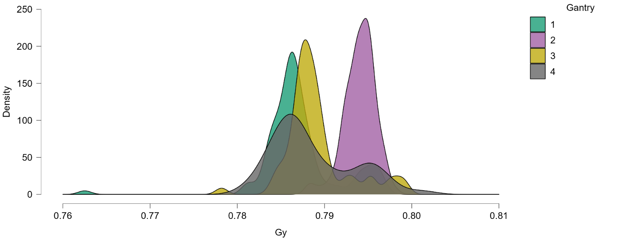

**80**

**90**

**100**

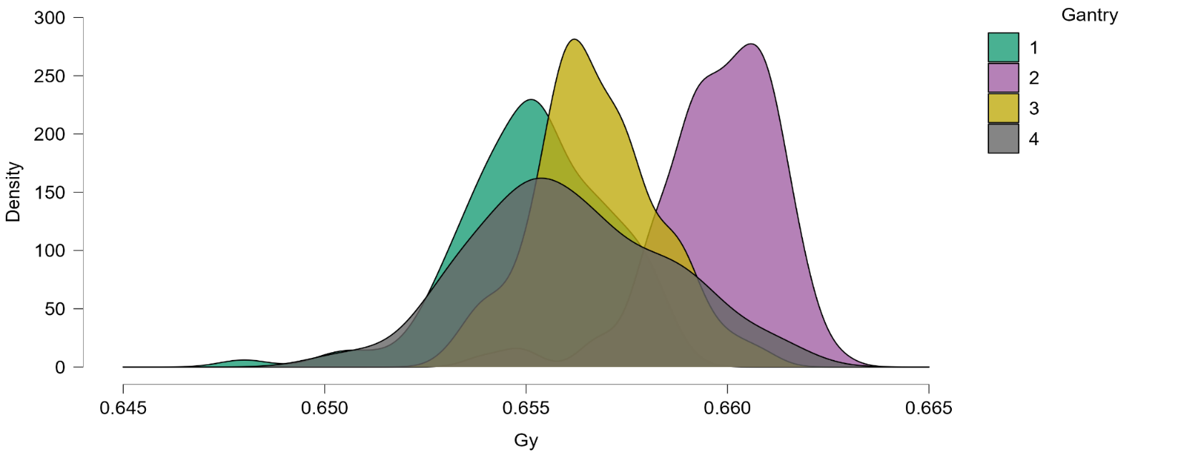

**110**

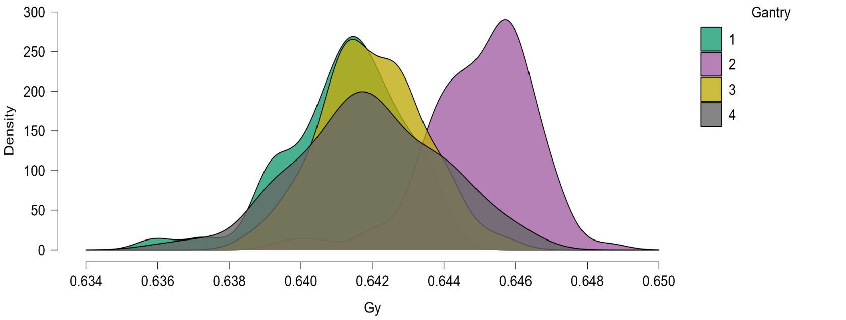

**120**

**130**

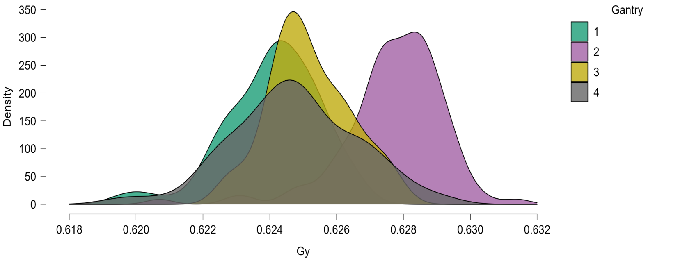

**140**

**150**

**160**

**170**

**180**

**190**

**200**

**210**

**220**

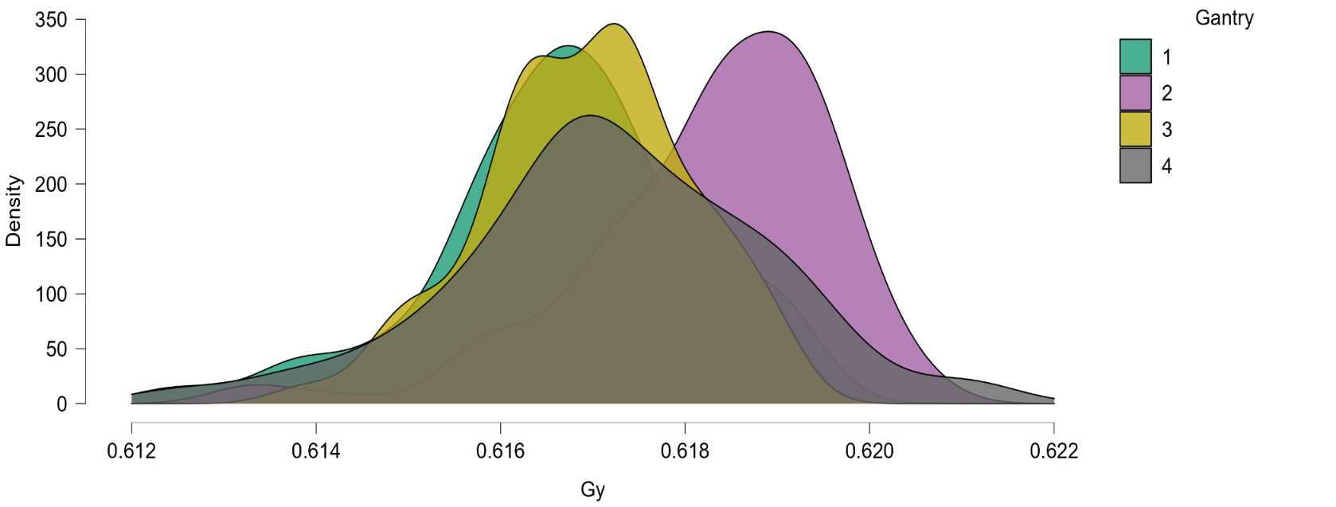

**230**

**240**

**Figure 2 Frequency distribution of dose consistency output - Gantry 1 - all energies superposed**

**Figure 3 Frequency distribution of dose consistency output - Gantry 2 - all energies superposed**

**Figure 4 Frequency distribution of dose consistency output - Gantry 3 - all energies superposed**

**Figure 5 Frequency distribution of dose consistency output - Gantry 4 - all energies superposed**

# Range of readings – indicative plots by gantry (and energy)

Some interest was expressed to examine the range between the individual readings within a single estimate of dose for a given energy (a row in the spreadsheet).

Range among separate readings taken for output plotted by Gantry (and energy): NB in these tables and plot, the ‘range’ has been multiplied by 100 to help with the visualisation of the RELATIVE variation in range between readings between the gantries (where such a range can be sensibly defined – ie more than one reading).

**Figure 6 Range Among separate readings taken for output represented by rectanglesfor each part of range value**

**Plotted by Gantry (and divided into Energy bands)**

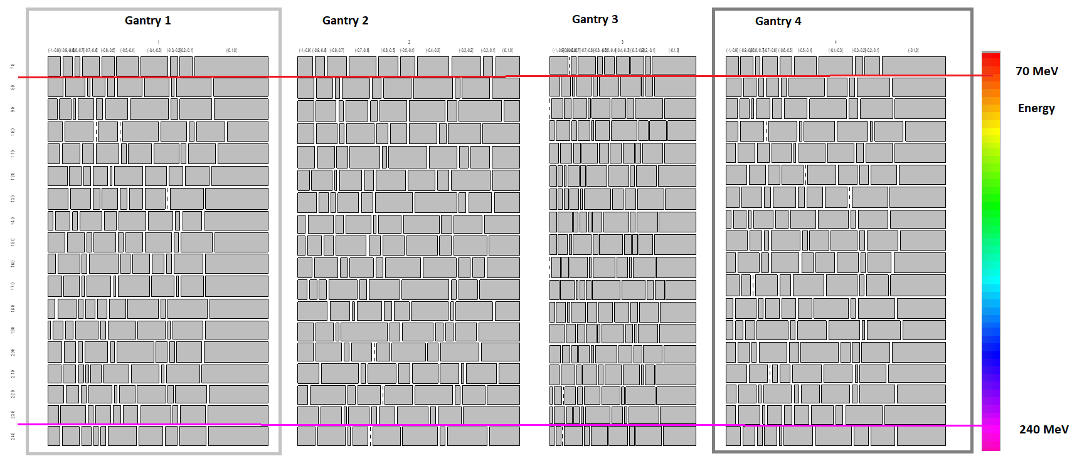

# Plots of Dose measured by time

Following an inspection of the previous dataset, the set were rexported. The import into R used a parser that could type the data into columns and assign R class such as ‘double’ for numeric data, “date” for date formatted strings with appropriate decoding, and “factor” for potential influence factors in an analysis such as the chamber serial number, the gantry number (eg Gantry 1) and so forth.

Using technology in R to store the data in highlevel data storage objects (in R environment) permits relatively straightforward query and filter of the dataset to derive potentially useful extracts for graphing or further analysis.

The following graphs were derived following an example in the timetk CRAN/website/github site.

NB CAVEAT currently I have not identified what the techniques used to plot the ‘fit line’ in the tabulated curves, and NO data has been rejected from the input ‘raw files’ exported from monthly excel files.

<https://cran.r-project.org/web/packages/timetk/vignettes/TK04_Plotting_Time_Series.html>

**Figure 7 High Energies, Gantry 4**

**Figure 8 High Energies, Gantry 3**

**Figure 9 High Energies, Gantry 2**

**Figure 10 High Energies, Gantry 1**

**Figure 11 Low Energies, Gantry 4**

**Figure 12 Low Energies, Gantry 3**

**Figure 13 Low Energies, Gantry 2**

**Figure 14 Low Energies, Gantry 1**

# Appendices

## Material too voluminous to include in report

# Range of readings (rows of repeated charge readings in data)

## Tables: Range Among separate readings taken for output Plotted by Gantry (and divided into Energy bands)

, , CleanRangeF = (-1,-0.9] **LARGEST RANGE**

|  |  |  |  |  |  |  |  |  |  |  |  |  |  |  |  |  |  |  |  |
| --- | --- | --- | --- | --- | --- | --- | --- | --- | --- | --- | --- | --- | --- | --- | --- | --- | --- | --- | --- |
| GANTRY | 70 | 80 | 90 | 100 | 110 | 120 | 130 | 140 | 150 | 160 | 170 | 180 | 190 | 200 | 210 | 220 | 230 | 240 |  |
| 1 | 5 | 6 | 4 | 6 | 5 | 8 | 9 | 2 | 7 | 3 | 6 | 3 | 1 | 6 | 5 | 6 | 4 | 5 |  |
| 2 | 6 | 7 | 7 | 7 | 8 | 5 | 8 | 3 | 3 | 6 | 4 | 12 | 6 | 6 | 9 | 4 | 8 | 7 |  |
| 3 | 7 | 4 | 0 | 2 | 4 | 3 | 3 | 3 | 3 | 0 | 4 | 2 | 6 | 4 | 4 | 1 | 1 | 2 |  |
| 4 | 5 | 6 | 5 | 5 | 4 | 9 | 6 | 2 | 9 | 4 | 6 | 3 | 3 | 4 | 8 | 4 | 4 | 6 |  |

, , CleanRangeF = (-0.9,-0.8]

|  |  |  |  |  |  |  |  |  |  |  |  |  |  |  |  |  |  |  |  |
| --- | --- | --- | --- | --- | --- | --- | --- | --- | --- | --- | --- | --- | --- | --- | --- | --- | --- | --- | --- |
|  | 70 | 80 | 90 | 100 | 110 | 120 | 130 | 140 | 150 | 160 | 170 | 180 | 190 | 200 | 210 | 220 | 230 | 240 |  |
| 1 | 4 | 8 | 5 | 12 | 8 | 5 | 9 | 6 | 7 | 9 | 7 | 8 | 4 | 5 | 5 | 5 | 10 | 7 |  |
| 2 | 4 | 7 | 9 | 9 | 8 | 9 | 4 | 10 | 6 | 10 | 3 | 8 | 7 | 10 | 16 | 14 | 8 | 11 |  |
| 3 | 0 | 4 | 5 | 6 | 5 | 2 | 2 | 6 | 4 | 4 | 6 | 4 | 4 | 3 | 6 | 3 | 4 | 2 |  |
| 4 | 5 | 5 | 4 | 10 | 7 | 7 | 9 | 5 | 5 | 9 | 4 | 9 | 3 | 5 | 7 | 7 | 9 | 5 |  |

, , CleanRangeF = (-0.8,-0.7]

|  |  |  |  |  |  |  |  |  |  |  |  |  |  |  |  |  |  |  |  |
| --- | --- | --- | --- | --- | --- | --- | --- | --- | --- | --- | --- | --- | --- | --- | --- | --- | --- | --- | --- |
|  | 70 | 80 | 90 | 100 | 110 | 120 | 130 | 140 | 150 | 160 | 170 | 180 | 190 | 200 | 210 | 220 | 230 | 240 |  |
| 1 | 2 | 1 | 1 | 0 | 5 | 3 | 3 | 2 | 2 | 2 | 1 | 2 | 3 | 2 | 2 | 2 | 2 | 4 |  |
| 2 | 8 | 2 | 2 | 2 | 5 | 1 | 2 | 3 | 4 | 3 | 3 | 1 | 1 | 2 | 2 | 3 | 1 | 1 |  |
| 3 | 2 | 1 | 3 | 2 | 3 | 1 | 2 | 2 | 1 | 3 | 1 | 1 | 3 | 2 | 2 | 0 | 2 | 0 |  |
| 4 | 2 | 2 | 1 | 0 | 5 | 5 | 3 | 1 | 2 | 3 | 0 | 2 | 4 | 2 | 0 | 1 | 1 | 2 |  |

, , CleanRangeF = (-0.7,-0.6]

|  |  |  |  |  |  |  |  |  |  |  |  |  |  |  |  |  |  |  |  |
| --- | --- | --- | --- | --- | --- | --- | --- | --- | --- | --- | --- | --- | --- | --- | --- | --- | --- | --- | --- |
|  | 70 | 80 | 90 | 100 | 110 | 120 | 130 | 140 | 150 | 160 | 170 | 180 | 190 | 200 | 210 | 220 | 230 | 240 |  |
| 1 | 7 | 5 | 7 | 8 | 10 | 6 | 7 | 9 | 9 | 12 | 11 | 4 | 9 | 10 | 1 | 9 | 6 | 2 |  |
| 2 | 11 | 12 | 10 | 12 | 14 | 10 | 9 | 10 | 13 | 10 | 12 | 10 | 18 | 8 | 12 | 9 | 8 | 6 |  |
| 3 | 7 | 6 | 6 | 5 | 7 | 5 | 4 | 3 | 8 | 8 | 2 | 6 | 4 | 4 | 6 | 4 | 2 | 8 |  |
| 4 | 6 | 5 | 6 | 12 | 8 | 9 | 10 | 8 | 12 | 12 | 10 | 6 | 13 | 12 | 2 | 11 | 6 | 5 |  |

, , CleanRangeF = (-0.6,-0.5] **MIDDLE RANGE**

|  |  |  |  |  |  |  |  |  |  |  |  |  |  |  |  |  |  |  |  |
| --- | --- | --- | --- | --- | --- | --- | --- | --- | --- | --- | --- | --- | --- | --- | --- | --- | --- | --- | --- |
|  | 70 | 80 | 90 | 100 | 110 | 120 | 130 | 140 | 150 | 160 | 170 | 180 | 190 | 200 | 210 | 220 | 230 | 240 |  |
| 1 | 5 | 3 | 3 | 0 | 2 | 1 | 3 | 5 | 2 | 4 | 1 | 4 | 2 | 2 | 4 | 1 | 3 | 2 |  |
| 2 | 8 | 4 | 3 | 5 | 2 | 4 | 5 | 1 | 5 | 3 | 3 | 3 | 4 | 0 | 5 | 0 | 2 | 0 |  |
| 3 | 2 | 2 | 1 | 1 | 4 | 2 | 1 | 1 | 2 | 1 | 2 | 4 | 1 | 1 | 2 | 2 | 1 | 2 |  |
| 4 | 5 | 2 | 4 | 1 | 1 | 0 | 3 | 5 | 2 | 5 | 5 | 6 | 2 | 4 | 4 | 2 | 3 | 1 |  |

, , CleanRangeF = (-0.5,-0.4]

|  |  |  |  |  |  |  |  |  |  |  |  |  |  |  |  |  |  |  |  |
| --- | --- | --- | --- | --- | --- | --- | --- | --- | --- | --- | --- | --- | --- | --- | --- | --- | --- | --- | --- |
|  | 70 | 80 | 90 | 100 | 110 | 120 | 130 | 140 | 150 | 160 | 170 | 180 | 190 | 200 | 210 | 220 | 230 | 240 |  |
| 1 | 9 | 10 | 10 | 15 | 10 | 12 | 6 | 11 | 7 | 7 | 14 | 7 | 11 | 16 | 10 | 6 | 6 | 12 |  |
| 2 | 6 | 12 | 12 | 7 | 18 | 13 | 16 | 9 | 9 | 15 | 13 | 6 | 12 | 5 | 11 | 11 | 6 | 11 |  |
| 3 | 4 | 8 | 8 | 6 | 5 | 9 | 12 | 4 | 10 | 10 | 12 | 6 | 9 | 8 | 7 | 6 | 9 | 7 |  |
| 4 | 9 | 14 | 10 | 13 | 11 | 12 | 7 | 10 | 8 | 8 | 14 | 6 | 12 | 16 | 11 | 7 | 6 | 12 |  |

, , CleanRangeF = (-0.4,-0.3]

|  |  |  |  |  |  |  |  |  |  |  |  |  |  |  |  |  |  |  |  |
| --- | --- | --- | --- | --- | --- | --- | --- | --- | --- | --- | --- | --- | --- | --- | --- | --- | --- | --- | --- |
|  | 70 | 80 | 90 | 100 | 110 | 120 | 130 | 140 | 150 | 160 | 170 | 180 | 190 | 200 | 210 | 220 | 230 | 240 |  |
| 1 | 11 | 10 | 17 | 11 | 11 | 9 | 9 | 10 | 11 | 5 | 10 | 13 | 11 | 5 | 11 | 11 | 12 | 10 |  |
| 2 | 13 | 17 | 16 | 12 | 13 | 12 | 18 | 14 | 13 | 14 | 20 | 15 | 3 | 13 | 8 | 15 | 12 | 14 |  |
| 3 | 5 | 8 | 6 | 11 | 5 | 9 | 5 | 11 | 3 | 5 | 10 | 6 | 3 | 5 | 7 | 7 | 4 | 8 |  |
| 4 | 14 | 8 | 16 | 13 | 11 | 8 | 10 | 12 | 11 | 9 | 14 | 15 | 13 | 4 | 11 | 11 | 9 | 15 |  |

, , CleanRangeF = (-0.3,-0.2]

|  |  |  |  |  |  |  |  |  |  |  |  |  |  |  |  |  |  |  |  |
| --- | --- | --- | --- | --- | --- | --- | --- | --- | --- | --- | --- | --- | --- | --- | --- | --- | --- | --- | --- |
|  | 70 | 80 | 90 | 100 | 110 | 120 | 130 | 140 | 150 | 160 | 170 | 180 | 190 | 200 | 210 | 220 | 230 | 240 |  |
| 1 | 3 | 1 | 3 | 2 | 2 | 6 | 0 | 2 | 2 | 2 | 1 | 2 | 1 | 2 | 1 | 2 | 2 | 5 |  |
| 2 | 12 | 2 | 4 | 3 | 4 | 5 | 3 | 4 | 5 | 5 | 2 | 1 | 3 | 4 | 1 | 2 | 2 | 2 |  |
| 3 | 5 | 1 | 3 | 4 | 2 | 2 | 5 | 2 | 2 | 1 | 3 | 3 | 1 | 3 | 1 | 1 | 1 | 2 |  |
| 4 | 3 | 2 | 4 | 1 | 3 | 4 | 0 | 2 | 2 | 2 | 2 | 2 | 1 | 3 | 1 | 2 | 3 | 6 |  |

, , CleanRangeF = (-0.2,-0.1]

|  |  |  |  |  |  |  |  |  |  |  |  |  |  |  |  |  |  |  |  |
| --- | --- | --- | --- | --- | --- | --- | --- | --- | --- | --- | --- | --- | --- | --- | --- | --- | --- | --- | --- |
|  | 70 | 80 | 90 | 100 | 110 | 120 | 130 | 140 | 150 | 160 | 170 | 180 | 190 | 200 | 210 | 220 | 230 | 240 |  |
| 1 | 5 | 14 | 14 | 12 | 12 | 10 | 15 | 8 | 13 | 12 | 10 | 17 | 12 | 11 | 13 | 12 | 10 | 11 |  |
| 2 | 4 | 12 | 19 | 14 | 9 | 17 | 10 | 11 | 14 | 5 | 8 | 15 | 8 | 15 | 13 | 9 | 9 | 16 |  |
| 3 | 2 | 3 | 12 | 7 | 9 | 9 | 12 | 9 | 6 | 10 | 4 | 8 | 8 | 7 | 4 | 11 | 11 | 11 |  |
| 4 | 6 | 13 | 14 | 12 | 11 | 11 | 16 | 12 | 13 | 10 | 10 | 16 | 14 | 12 | 10 | 14 | 15 | 10 |  |

, , CleanRangeF = (-0.1,0] **LOWEST RANGE**

|  |  |  |  |  |  |  |  |  |  |  |  |  |  |  |  |  |  |  |  |
| --- | --- | --- | --- | --- | --- | --- | --- | --- | --- | --- | --- | --- | --- | --- | --- | --- | --- | --- | --- |
|  | 70 | 80 | 90 | 100 | 110 | 120 | 130 | 140 | 150 | 160 | 170 | 180 | 190 | 200 | 210 | 220 | 230 | 240 |  |
| 1 | 30 | 22 | 24 | 17 | 22 | 24 | 28 | 26 | 22 | 26 | 28 | 25 | 25 | 28 | 26 | 23 | 24 | 25 |  |
| 2 | 10 | 12 | 7 | 16 | 13 | 12 | 11 | 14 | 13 | 14 | 17 | 10 | 16 | 15 | 9 | 13 | 22 | 12 |  |
| 3 | 17 | 17 | 14 | 12 | 14 | 17 | 14 | 16 | 18 | 18 | 13 | 15 | 15 | 12 | 17 | 15 | 13 | 14 |  |
| 4 | 26 | 21 | 22 | 17 | 21 | 20 | 25 | 22 | 19 | 22 | 25 | 21 | 18 | 23 | 22 | 19 | 25 | 20 |  |

## Heatmaps Dose Gy chambers by energy and gantry

**This is a representation of relative response of the chambers by energy and gantry. (are you sure?)**

|  |  |  |
| --- | --- | --- |
| 70 MeV  70 | 80 MeV  80 | 90 MeV  90 |
|  |  |  |

|  |  |  |
| --- | --- | --- |
|  |  |  |
|  |  |  |

|  |  |  |
| --- | --- | --- |
|  |  |  |
|  |  |  |